# User Document

**Welcome to this program!** This program is a Python based simulation model that can be used to model resource sharing in multi-intelligent systems. The following are detailed instructions for using this program:

1. Before running the program, make sure that you have the following Python libraries installed: matplotlib, tkinter, operator, imageio, requests and bs4. If you do not have them installed, you can install them in the terminal using the following command:

`pip install matplotlib tkinter operator imageio requests bs4`

1. Before you start, make sure you have created the input files in.txt and environment.txt. These two files should be located in the same directory as this program. See below for a detailed description of these two files.
2. To start the program: Start the program in the terminal using the following command:

`python main.py`

1. Once the program is running, you will see a GUI interface.

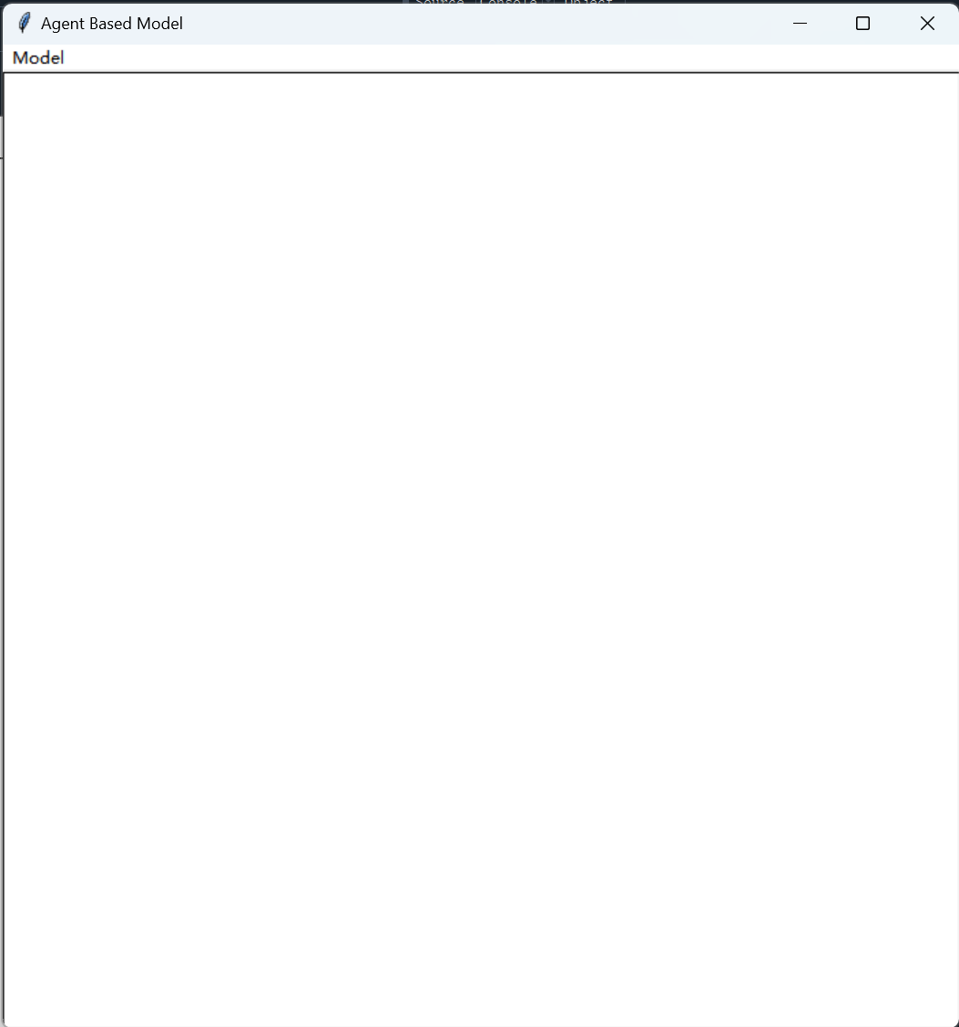

You can set the parameters of the model in the interface and click on the "Run" button to start the simulation.

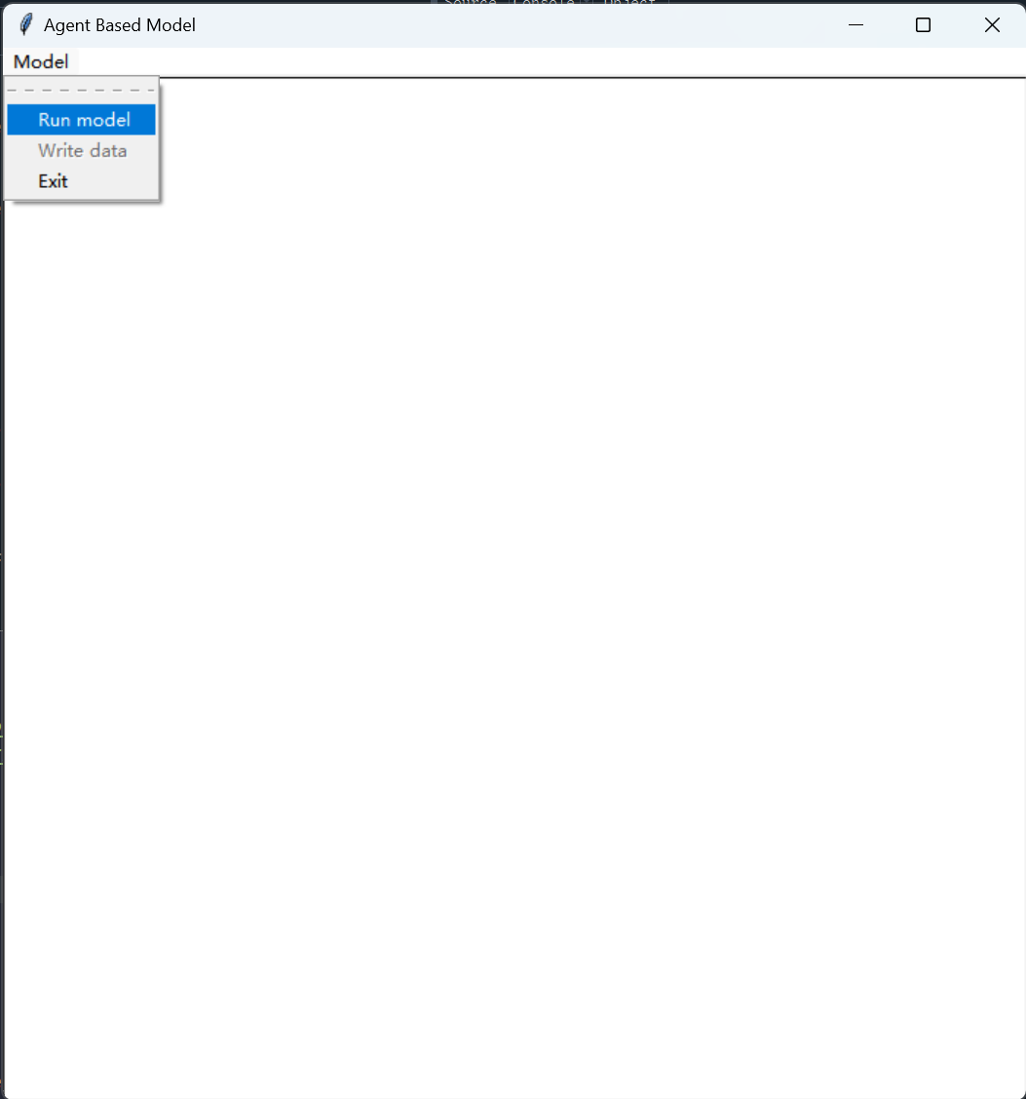

Once the simulation is complete, you can see the final result.

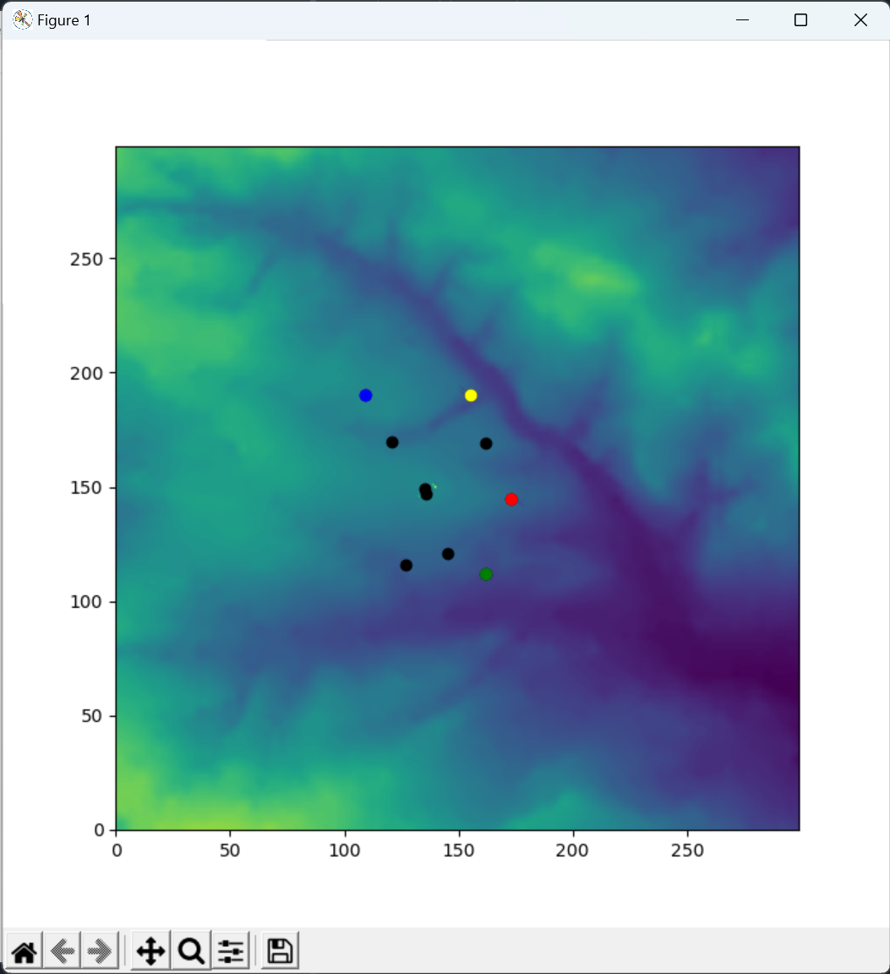

The process of the simulation would be saved as a GIF animation.



1. Input file description:

* in.txt: This file contains an integer that represents the number of intelligences in the simulation.
* environment.txt: This file should be a CSV file where each row represents a row of resource values for the environment grid and each column represents a column of resource values for the environment grid. The file should contain the same number of rows and columns as the number of environment grids set in the program.

In the program we offer the following functions:

1. You can change the settings of the simulation by changing the concentration of food and the number of agents in the environment.
2. You can save the images of each iteration during the simulation and merge them into a GIF animation when the simulation is complete.
3. You can use the program output to evaluate the success of the simulation.

Thank you for using our program and we hope you enjoy it!